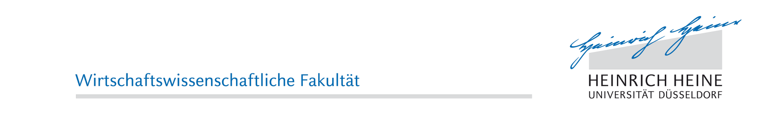
Ursula Hilgers  Ursula is a second-year master student at the Heinrich-Heine-Universität Düsseldorf, majoring in Entrepreneurial Management, Marketing and Human Resources. She earned a bachelor’s degree in Business Administration in 2015. As an enrichment of her studies, she spent a semester abroad at the École Supérieure de Commerce de Grenoble in France. She gained practical experience through working student employments and several internships in Germany and France. In her free time, Ursula enjoys to dance and travel. | 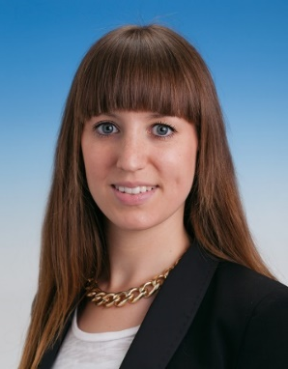
Hannes Kurz  Hannes is a second‐year master student at the Heinrich‐Heine‐Universität Düsseldorf, majoring in Finance and Accounting. He earned a bachelor’s double degree in Economics with a major in Business at the University of Erlangen-Nürnberg and in Financial Management at the University of Hull, England. He completed an apprenticeship as a bank clerk before his studies. During a gap year, he completed an internship at PricewaterHouseCoopers, gaining experience in business recovery services. In addition, he got knowledge in strategic management due to a half-year internship at a German mid-sized food production enterprise. In his leisure time, Hannes likes cooking and sports. | 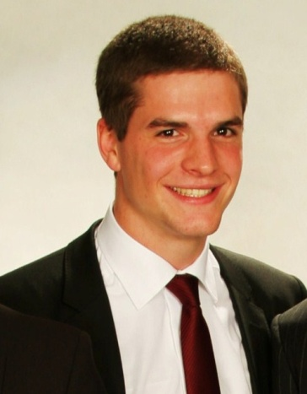
Johannes Gerlach  Johannes is a second-year master student at the Heinrich-Heine-Universität, specialising in Banking and Finance. He enriched his master with a semester abroad in Aberystwyth (Wales, UK), where he focused on financial regulation and emerging markets. He earned his bachelor’s degree in 2014 in economics and finance, which was combined with an apprenticeship as a bank clerk. Johannes gained practical experience in his apprenticeship and through activities as a working student. In his spare time, he likes doing water sports and winter sports. | 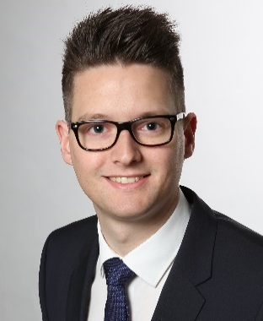
Louisa Schüßler  Louisa is a second-year master student at Heinrich‐Heine‐Universität Düsseldorf, majoring in Entrepreneurial Management, Marketing and Human Resources Management. She earned her Bachelor’s degree in business administration at Westfälische Wilhelms-Universität Münster. Before going to university, she spent two years at Bromsgrove School in England accomplishing the International Baccalaureate Diploma. Whilst improving her English skills, she also gained intercultural experience. Being a working student at KPMG AG she acquired practical experience in the field of consulting. In her leisure time, Louisa enjoys doing sports and traveling. | 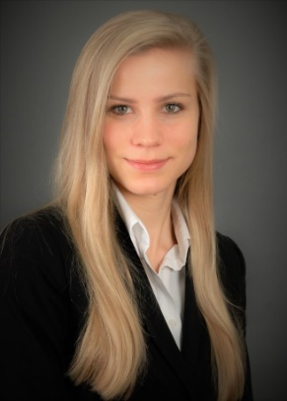
David Stüve  David is a second-year master student at the Heinrich-Heine-Universität Düsseldorf, majoring in Entrepreneurial Management and Entrepreneurial Finance. He earned a bachelor’s degree in International Business Administration from the University of Twente in Enschede, Netherlands. David enriched his studies with a semester abroad at the Charles University in Prague and gained practical experience during internships in Supply Chain Management and Consulting. In his leisure time, he enjoys playing football, travelling and hiking. | 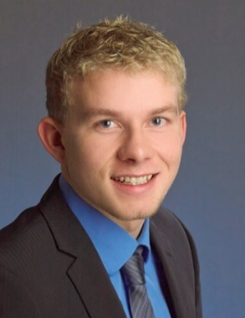
Coaches

Christian Schwens (Coach)  Christian is full Professor for Management at the Heinrich-Heine-Universität Düsseldorf. He received his PhD from the University of Giessen. In 2006 he was visiting scholar at the Carlson School of Management at the University of Minnesota. Christian studied business administration at the University of Paderborn and the University of Stockholm. He won the Spirit Award while participating in the MBA-ICC in 2004 as a member of the team Paderborn. His research interests include international entrepreneurship, internationalization of small- and medium-sized enterprises and CEO personality traits. | 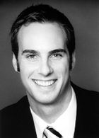Prof. Dr. Christian Schwens  christian.schwens@hhu.de
Sarah Türk (Coach)  Sarah was a member of Team Düsseldorf at the 34st MBA ICC 2015 and is now a PhD candidate in Management at the Heinrich-Heine-Universität Düsseldorf. Her research currently focuses on entrepreneurial intentions. During her studies at the universities of Münster and Düsseldorf Sarah specialized in Management, Marketing and Human Resources. As an enrichment of her academic education, she spent parts of her studies abroad at the Corvinus University in Budapest and working for a social organization in Mauritius. During several internships, she gained practical experiences in strategy and financial consulting. Sarah is passionate about travelling and doing sports. | 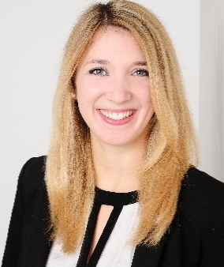  Sarah Türk, M.Sc.  sarah.tuerk@hhu.de
Peter Mandel (Coach)  Peter was a member of Team Düsseldorf at the 35st MBA ICC 2016 and is now a second-year master student in Economics at the Heinrich-Heine-Universität Düsseldorf, majoring in Econometrics. He earned his bachelor’s degree in Business Administration at the University of Göttingen with a major in Strategic Management. Besides pursuing his master’s degree, Peter gains profound practical insights working for a strategy-consulting firm in the position of a Junior Consultant. His work is centered on developing market-based strategies using advanced analytic techniques. In his leisure time, Peter practices Wing Chun and travels around the world. | 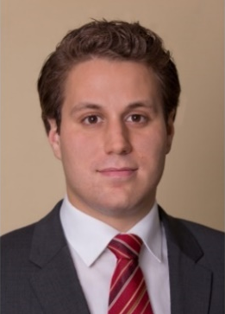  Peter Mandel, B.Sc.  peter.mandel@hhu.de

